OWNERSHIP CERTIFICATE
To Whom It May Concern

This is to certify that the following equipment listed below is the sole property of Sudhir Equipment Rental Company

Equipment | Forklift
Brand / Make | HELI
Asset ID | S3FLT-028
Model Number | CPCD30
Serial Number | 010302P8068
Manufacturing Year | 2022

This certification is issued to confirm the ownership status of the aforementioned equipment. Sudhir Equipment Rental Company holds full legal ownership rights over the listed equipment and retains all associated benefits and responsibilities.
Should there be any queries or requests for verification regarding the ownership of the mentioned equipment, please do not hesitate to contact us at : Info@sudhirrentals.com

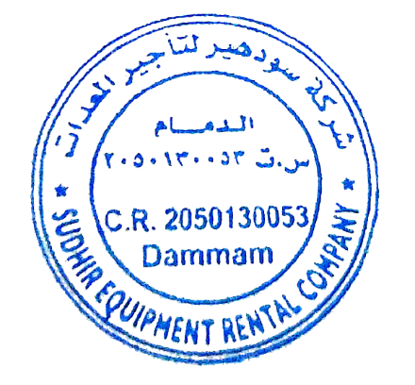
Sincerely,

Sudhir Equipment Rental Company

